***Trails Committee: New Trail Plans: Access Paths from Airline Trail and More…***

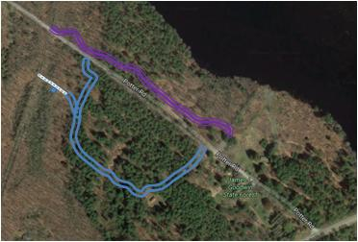

2017 will see construction of two new access paths from the Airline Trail to the Goodwin Center. One trail will connect to the Forest Discovery (Blue-Red) Trail and will include a boardwalk and observation platform through a wetlands area. The other will provide access for horse riders to the parking area opposite the Center. Both paths were roughed out prior to the Timber Harvest and can proceed once that activity is completed. Materials for the boardwalk area including support pontoons and lumber have already been procured through CFPA funding. The horse path will be worked first since it will be necessary to wait for dry conditions in the wetlands area before constructing the boardwalk and platform. The horse path will provide a direct route from the Airline Trail without horse riders needing to use Potter Rd or the Forest Discovery Trail which was closed to horses last year.

In addition to these two access paths, a new extension of the Orange Trail will provide hikers and others a blazed loop trail to the Northern boundary of Goodwin Forest. This loop trail will extend past Orchard Hill and along the edge of the Natchaug Forest and then will loop back to connect with the Blue-White Trail.

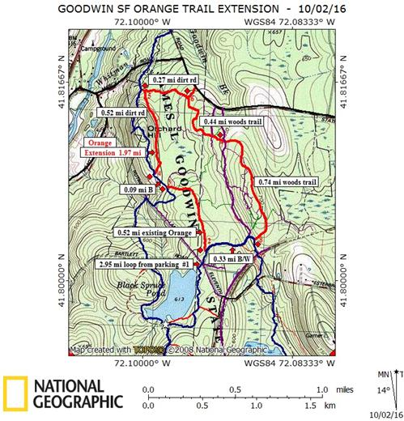

Finally, Goodwin has submitted a proposal through CFPA for adding a Universal Access Path to the Garden Area. The plan, if accepted by DEEP for funding will be in two phases. The initial phase will be a short path from a handicap parking spot behind the Center over to the existing ramps of the main building and the museum. That will allow for some experience with maintenance. The second phase is a longer section that will access the Potter Rd crossing to the parking area and also loop through the gardens.