James L. Goodwin Conservation Center Volunteer Handbook | Working to Provide Forestry, Wildlife, and General Conservation Education to Youth and Adults.

Contents
Welcome 2
History 3
Programs 6
Benefits of Being a James L. Goodwin Conservation Center Volunteer 8
Online Volunteer Center 10
Requirements 11
Legal info 12
Time to say goodbye 13
Volunteer Time Reporting System Walk-through 14

Volunteering at the James L. Goodwin Conservation Center (JGCC)

Welcome
Congratulations on joining a vibrant community of volunteers at James L. Goodwin State Forest & Conservation Center! You are part of a rich history that began in 1964, when James L. Goodwin gifted the entire property, what he called “Pine Acres Farm”, to the State of Connecticut after 50 years of state-of-the-art forestry management. The house and 80 surrounding acres were then designated as a forest and wildlife Conservation Center.
Since that time, the James L. Goodwin Conservation Center (JGCC) has grown as a strong example of the benefit of partnerships. The Conservation Center is managed jointly by the Connecticut Department of Energy & Environmental Protection (CT DEEP) and the Connecticut Forest & Park Association (CFPA), Connecticut’s oldest conservation organization.
James L. Goodwin was an early professional forester in the state of Connecticut. Following his wishes, today the James L. Goodwin Conservation Center offers a program of forestry, wildlife and general conservation education for youth and adults. Thousands enjoy hiking, biking or horseback riding on the 17 miles of trails surrounding the center, as well as paddling on Pine Acres Pond. The center offers year-round educational programs, a nature museum, and displays highlighting the 100+ years of forestry on the property. It also boasts the 1.5 acre Richard Haley Native Plant Wildlife Gardens, a demonstration forest where professional forest and wildlife stewardship practices are put into place, a youth group campsite, and a picnic pavilion that overlooks Pine Acres Pond.
Your interest in volunteering at the James L. Goodwin Conservation Center is the first step to helping preserve this important ecological, educational and historical resource for the future. Goodwin volunteers were integral in creating and maintaining the center that we enjoy today, including the trails, grounds, gardens and educational programs. Many of our volunteers are involved with Friends of Goodwin Forest (FGF). FGF’s mission is to advocate, enhance and support the education, recreation and conservation activities of the historic James L. Goodwin Forest and Conservation Center. If you are not already a member of this very important organization, I strongly encourage you to join by visiting www.friendsofgoodwinforest.org.
Whether you volunteer for one day or many years, your time at James L. Goodwin Conservation Center is valued and appreciated. JGCC has a small number of staff, and would not be able to maintain the high level of programming and facilities we offer without the help of our dedicated volunteers.
Welcome to the Goodwin community! We look forward to creating Goodwin’s future with you.

Thank you for your support,

Beth Rhines
Program Director

Volunteering at JGCC

History

About James L. James L. Goodwin Conservation Center
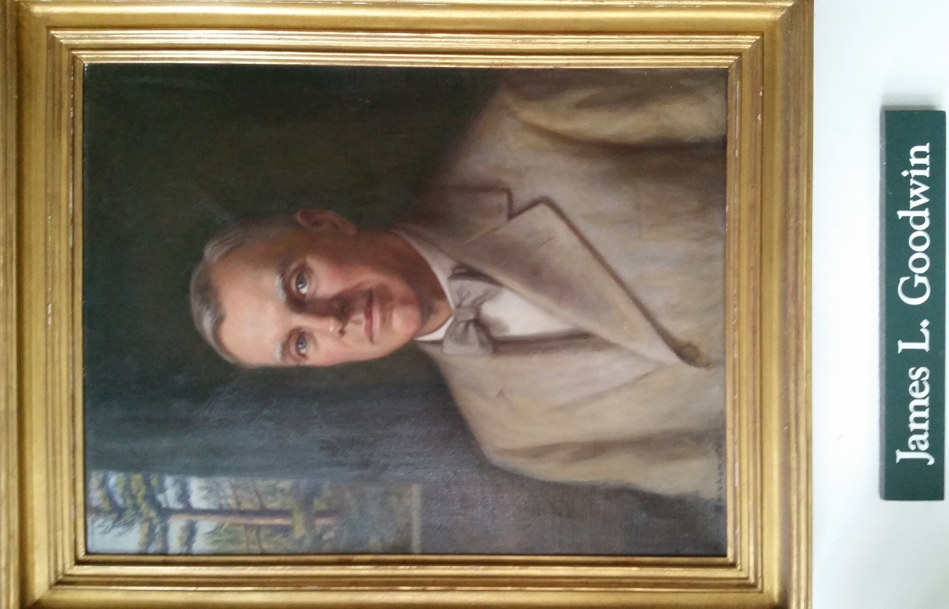
The James L. Goodwin Conservation Center and James L. Goodwin State Forest were gifts to the people of Connecticut from James L. Goodwin, one of America’s first professional foresters and a long-time CFPA Director. James L. Goodwin came to this property in Hampton in 1914, where he practiced 50 years of pioneering forest management techniques that he learned as one of the first foresters to graduate from Yale School of Forestry in 1910. He grew white pine for timber, sold Norway spruce for Christmas trees, and grew apple trees in his fields. He demonstrated a high level of forest stewardship in this area until he donated the property to the State of Connecticut in 1964 with the hopes that the center would continue to fulfill the mission of providing forestry, wildlife and general conservation to youth and adults.
Volunteerism has been an invaluable part of the James L. Goodwin Conservation Center since it was donated to the state in 1964. Throughout the years, our facility has expanded to provide more educational programs and more opportunities for outdoor recreation. Many of our trails have been designed, built, and maintained by the overwhelming support of volunteer efforts. In addition to our trails, volunteers have played an integral part in making so many of our programs successful, including our efforts to build and support the State Park system over its 100 year history.

A Unique Partnership
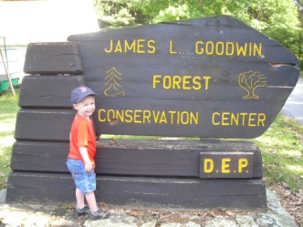
The James L. Goodwin Conservation Center represents a unique partnership managed jointly by the Connecticut Department of Energy & Environmental Protection Division of Parks and the Connecticut Forest & Park Association with the mission to provide forestry, wildlife, and general conservation education to youth and adults. The Conservation Center works in partnership with the Friends of Goodwin Forest to sustain this mission.
When you volunteer for the programs and events listed in this handbook, you are a volunteer for the James L. Goodwin Conservation Center. Because of our unique partnership, our volunteers can also be supporting the Connecticut Forest & Park Association, The Department of Energy and Environmental Protection, and the Friends of Goodwin Forest. Goodwin volunteers are expected to uphold the standards and practices of all of these partners as they gain added benefits from these diverse relationships.
The staff at the James L. Goodwin Conservation Center staff may be small but is very powerful thanks to the support of volunteers. The staff at JGCC prides itself on being a cooperative group of professionals working to advance conservation, outdoor recreation, and general appreciation for nature in the state of Connecticut. We welcome volunteers to this work in every way possible.

About Friends of Goodwin Forest
The mission of the Friends of Goodwin Forest is to advocate, enhance and support the education, recreation and conservation activities of the historic James L. James L. Goodwin Conservation Center. For more information or to become a member, visit www.friendsofgoodwinforest.org.

About CFPA
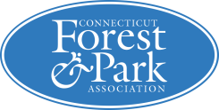
The history of CFPA is dynamic and rich, and has influences in most major conservation efforts in Connecticut with a focus on the health and management of our woodland resources. CFPA was founded in 1895 when a group of concerned citizens looked out over the Connecticut landscape and saw a dramatic absence of forests. In 1895, CT was only 20% forested, which is significantly lower than the 60% we have today. The group was originally named the Connecticut Forestry Association. They decided that they would work to protect the incredibly valuable financial and social assets that our forests have to offer through advocacy in the legislature and education of Connecticut’s people. Since the founding of this organization, the programs have been expanded to include the Blue-Blazed Hiking Trail System and an active Land Conservation and Management program. CFPA is a member-based organization which means we rely on dues from memberships to financially support our programs. Please consider joining the organization as a member if you haven’t already done so. For more information, visit www.ctwoodlands.org.
CFPA has proudly published important information regarding forestry, outdoor recreation, and conservation in Connecticut for its entire history. We are currently responsible for the following publications and resources:

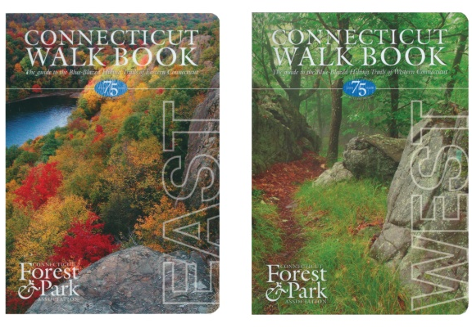
Connecticut Walk Book
The Connecticut Walk Book a comprehensive guide to the Blue-Blazed Hiking Trail System that we publish. The 19th edition is published in two volumes, Connecticut Walk Book East and Connecticut Walk Book West. The Blue-Blazed Metacomet Trail and Mattabesett Trail are the dividing point between east and west and appear in both volumes.
The Connecticut Walk Book West was selected as a "Work of Significance" by the National Outdoor Book Awards (NOBA) in 2007. The purpose of the award is to recognize and encourage outstanding writing and publishing. The winners are chosen by a panel of judges consisting of educators, academics, book reviewers, authors, editors, and outdoor columnists from throughout the country. We are pleased and honored to receive this recognition from the outdoor world’s largest and most prestigious book award program.

Connecticut Woodlands
Since 1936, CFPA has published Connecticut Woodlands. This well-respected quarterly magazine has consistently been a resource filled with important and timely articles regarding all things conservation. We offer the magazine as a benefit to our members. CFPA also uses this magazine to feature the great work of our volunteers. Look for the Volunteer Spotlight piece found in select issues of Connecticut Woodlands.

Connecticut Trails Day Booklet
As a part of the National Trails Day celebration, CFPA has been the CT coordinator of the Connecticut Trails Day events since it began in 1993. Each year CFPA has coordinated with hundreds of volunteer leaders to create and distribute the Connecticut Trails Day Booklet. For the 2015 Trails Day celebration, there were 225 events in 133 CT towns, ensuring Connecticut was again the leader in total number of events.

Interactive Maps
CFPA maintains the Blue-Blazed Hiking Trails Interactive Map and the CFPA Protected Properties Interactive Map. These are both Google overlay maps that clearly outline all of the most recent information regarding our Trails and Protected Properties. Refer to the CFPA website to access these sites.

CFPA and Social Media
CFPA interacts with the outside world through social media with the use of a few social media platforms. The three main ones we have chosen to focus our efforts on are Facebook, YouTube, and Twitter. If you haven’t done so yet, please connect with us through these sites in order to see the most recent CFPA social media participation. Be sure to share us with all your friends too!!

About CT DEEP
The Connecticut Department of Energy and Environmental Protection (DEEP) is charged with conserving, improving and protecting the natural resources and the environment of the state of Connecticut as well as making cheaper, cleaner and more reliable energy available for the people and businesses of the state. The agency is also committed to playing a positive role in rebuilding Connecticut’s economy and creating jobs – and to fostering a sustainable and prosperous economic future for the state.
DEEP was established on July 1, 2011 with the consolidation of the Department of Environmental Protection, the Department of Public Utility Control, and energy policy staff from other areas of state government. The environmental protection agency had been established in 1971 at the dawn of the environmental movement, while the public utilities regulatory authority traces its roots back more than 150 years to the state’s Railroad Commission.
The DEEP is organized into three main branches:
- The Energy Branch includes the Public Utilities Regulatory Authority (PURA) – formerly the Department of Public Utility Control – which reviews rates for electricity, water, cable television and other utilities as well as a Bureau of Energy and Technology Policy, which develops forward-looking energy efficiency, infrastructure and alternative power programs.
- The Environmental Quality Branch is comprised of the Bureaus of Air Management, Materials Management and Compliance Assurance, and Water Protection and Land Reuse. These bureaus protect the air, land and water resources of the state by regulating air emissions, wastewater discharges and solid and hazardous wastes. Tools used include the development of regulations, policies and standards; permitting and enforcement; air and water quality monitoring; and public outreach and education.
- The Environmental Conservation Branch consists of two bureaus. The Bureau of Natural Resources is charged with managing the state’s natural resources (particularly fish, wildlife, and forests) through a program of regulation, management, research, and public education. The Bureau of Outdoor Recreation is charged with the conservation and management of statewide recreation lands and resources through the acquisition of open space and the management of resources, including state parks, to meet the outdoor recreation needs of the public.
The James L. Goodwin Conservation Center is managed by the CT DEEP, State Parks and Public Outreach Division. Established in 1913, the mission of the Connecticut State Park System is to provide natural resource based public recreational and educational opportunities through a system of state park and forest recreation areas, environmental centers and nature centers which provide an understanding of, access to, and enjoyment of the state’s historic, cultural and natural resources.
Programs of State Parks & Public Outreach Division
www.ct.gov/deep/StateParks
No Child Left Inside®: The Great Park Pursuit – www.NoChildLeftInside.org
National Environmental & Conservation Education Curricula: Project Learning Tree, Project WILD, Aquatic WILD, Project WET, and Food, Land & People
Sky’s the Limit Hiking Challenge – www.ct.gov/deep/SkystheLimit
CT State Parks Pocket Ranger® App www.youTube.com/DEEPvideos
Facebook.com/CTStateParks Twitter.com/CTStateParks @CTStateParks

Volunteering at JGCC

Programs
Volunteers play important roles at the James L. Goodwin Conservation Center. They provide invaluable assistance to the staff and the public. Trained volunteers also help to interpret for visitors the cultural, historical, natural and recreational resources of our facility.

Blue-Blazed Hiking Trails and Auxiliary Trails in the Forest
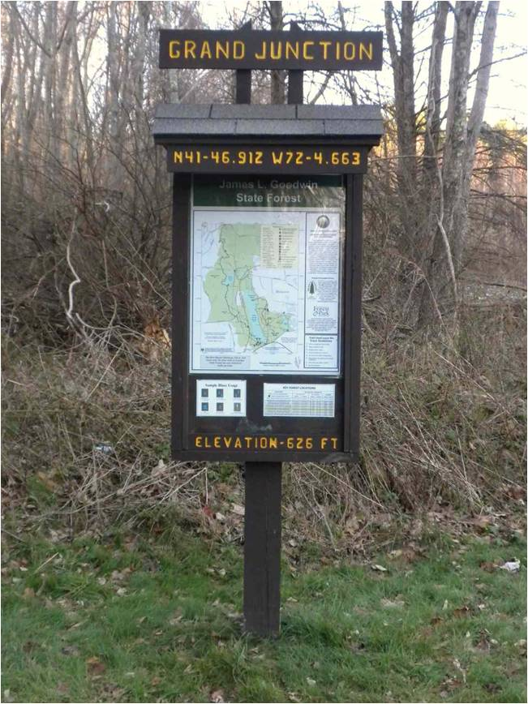
James L. Goodwin State Forest is privileged to have dedicated volunteers who build, maintain, and support its 17 miles of trails. Thousands of people have given countless hours to the 825 miles of the Blue-Blazed Hiking trail system; and the trails at Goodwin are a part of this effort, benefiting hikers, bikers and horseback riders alike. There are a number of ways you can contribute within this program. We are looking for hikers who can report on trail conditions, stewards who can adopt sections of trail and be responsible for ongoing maintenance, and volunteers who want to join trail work parties.

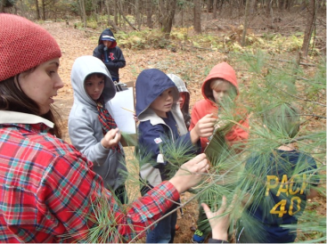
Environmental Education
Keeping in line with our mission, we have continually worked to connect people of all ages and backgrounds to the land. Our educational programs ensure learning in an outdoors, hands-on atmosphere. There are numerous valuable ways volunteers support our environmental education efforts including leading hikes, facilitating a school, scout, or Project Learning Tree program, assisting with our Master Naturalist program, or creating interpretive signage or brochures for the center.

Goodwin Gardeners
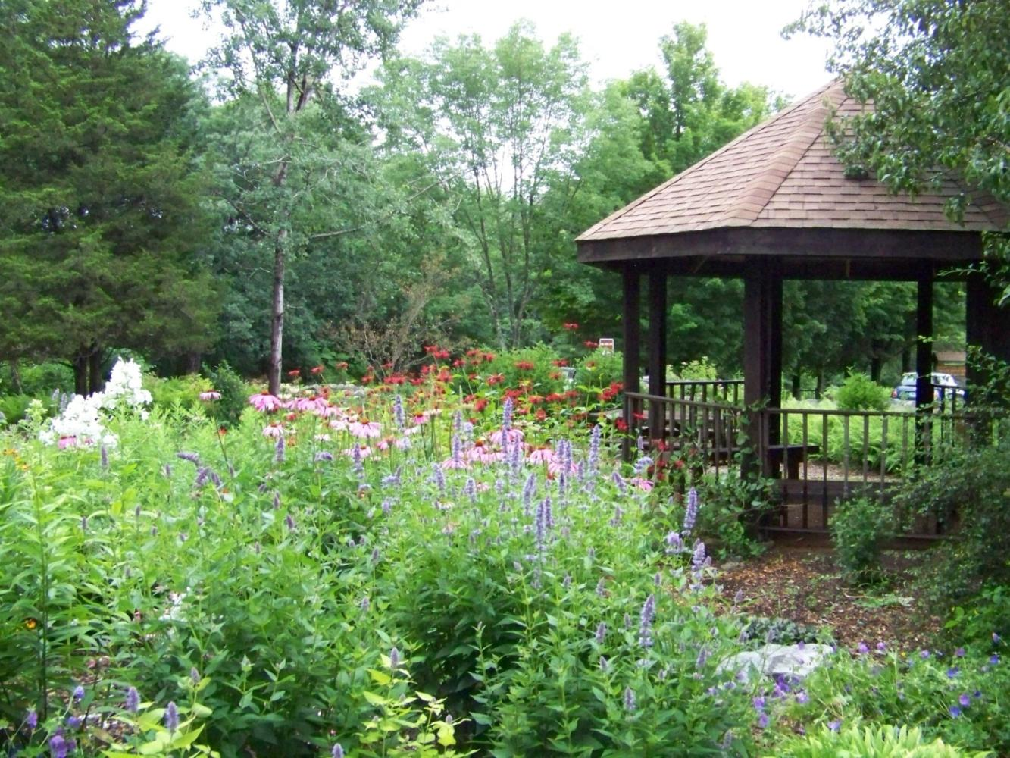
The extensive gardens, which include the Discovery Trail and the 1.6 acre Richard Haley Native Plant wildlife arboretum, offer a wide range of exciting volunteer opportunities. Learn more about sustainable landscaping from design to plant choice and soil preparation. Explore the incredible world of native plants with other like minded gardeners. Whether you are a very experienced gardener or want to learn ‘on the job’ the Goodwin Gardeners are an amazing team with a generosity of spirit that will have you looking forward to your next visit to the Center.

Historical/Museum
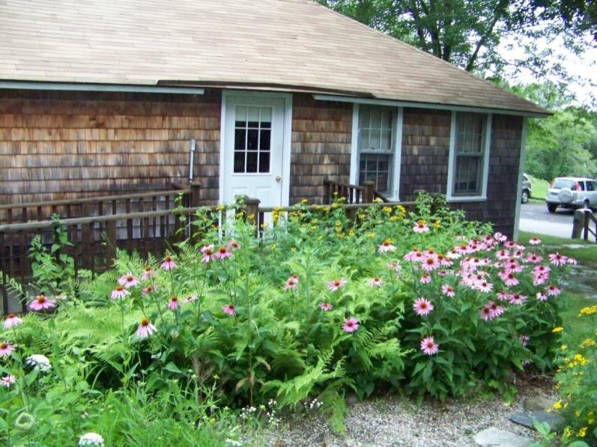
Historic artifacts, books and educational programming are utilized to keep the history of Pine Acres Farm alive today. Our nature museum also holds hundreds of specimens that are used on a regular basis for education and outreach. Volunteers are needed to help care for our collections, create interpretive displays, and tell the stories of Goodwin history.

Volunteering at JGCC

Programs (Continued)

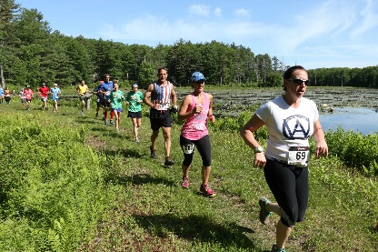
Special Events
There are a number of events hosted at James L. Goodwin Conservation Center every year, including the Trail Run, Plant Sale and volunteer work days. Volunteers are invited to help with one or all of these events. Off-site events are also an important of spreading the word about JGCC. We often look for volunteers who can travel to fairs and festivals to represent Goodwin at public events such as fairs and expos. Their valuable work gains exposure for Goodwin and secures membership support.

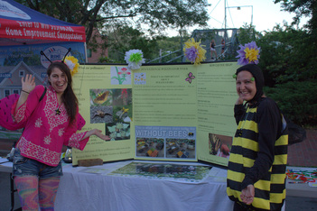
Organizational Support
Friends of Goodwin Forest relies on the support of members and donors. We have an active membership program and a fundraising/development program. James L. Goodwin Conservation Center seeks volunteer support for membership and development in our Friends organization. We also look for Ambassadors who represent James L. Goodwin Conservation Center at public events such as fairs and expos. JGCC also utilizes administrative volunteers to help with various projects in the office and beyond. These volunteers help with data entry, photography, communications and much more.

Volunteering at JGCC

Benefits of Being a JGCC Volunteer
The overall act of volunteering comes with many benefits, to the volunteer, to the sponsoring organization, and to the community as a whole. There are countless studies outlining the health and wellness benefit of volunteering. We at Goodwin Conservation Center feel that there are benefits, in addition to the general volunteerism benefit, that we are able to offer.

Giving Back
We hear time after time that our volunteers are so grateful for the opportunity to give back to Goodwin because they have appreciated the great work we have been able to accomplish.

Training
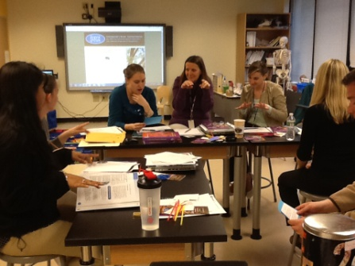
JGCC, with support from CT DEEP and CFPA, offers a Volunteer Orientation at least once each year, which will cover the historical, natural and recreational resources and Center activities. This will include information about the museum collections, arboretum, and interpretive techniques, and trails.
This is an opportunity to bring together a group of like-minded individuals to discuss the current needs of the organization. We use this time as a way for you, the volunteer, to get to know our organization and our mission better, and as a way for us to get to know you better. We hope that these orientations are fun, engaging, and act as a catalyst for you to find your place within the irreplaceable group of people Goodwin is proud to call volunteers.
In addition to the Volunteer Orientation, specific volunteer positions typically require additional training. These trainings are offered at little or no cost to the volunteer. Some of these trainings include, but are not limited to, First Aid/CPR certification and training on proper chainsaw safety. See the individual position descriptions to determine if further training is required.

Materials
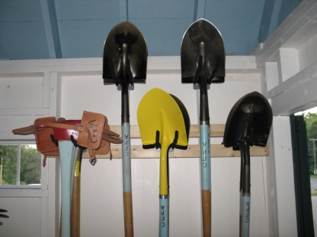
JGCC happily supports you, our volunteer, with the tools and materials you need to be successful in your work. Trails volunteers and Goodwin Gardeners are given access to tool sheds and the lumber and other materials needed for their work. Educational guides are given access to educational materials and engaging activities for their events. These are just two examples of the support the organization gives, if there is ever a need that arises during your service to Goodwin, please contact the JGCC Center Director to discuss this. They will gladly work with you to make you the most successful volunteer you can be.

Volunteering at JGCC

Benefits of Being a JGCC Volunteer (Continued)

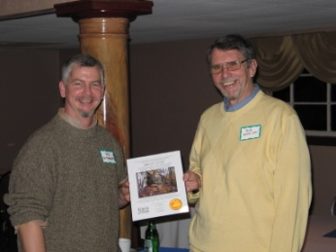
Recognition
The work of JGCC volunteers is important, timely, and interesting which is why we love to recognize them any chance we get. Through the Friends of Goodwin Forest Newsletter, Goodwin Open Houses, and Connecticut Woodlands, a CFPA quarterly magazine, we showcase our volunteers and the incredible effort and time they dedicate to their important projects. The amount of work our volunteers accomplish is so enormous that we are never short on great stories and people to feature in this way.
Another way we honor our volunteers is through the CFPA Annual Volunteer Dinner and Awards Banquet in early November. This invitation-only capstone event brings an amazing group of individuals together to socialize and highlight all the work accomplished over the past year. Every year we like to call out some of our exemplar volunteers with an award. Recipients of these awards are nominated by their peers, fellow volunteers, and supervisors in the organization. The CFPA Events and Volunteer Coordinator along with the entire Goodwin team have the hard task of narrowing these awards down to only a few. Every hour dedicated means so much to our organizations that it is quite challenging to call out only a select few volunteers.

Meet new people
While a lot of the work our volunteers do is self-led and may be accomplished by solo volunteers, a number of our programs utilize groups of volunteers together. Work parties, trainings, and other events can be a great opportunity for you to meet like-minded individuals within our community. We also welcome you to invite your friends to come along with you during your volunteer efforts to get them involved with JGCC as well.

Dollars for Doers and other Volunteer Grant Programs
As a volunteer, you have the opportunity to support this organization financially without having to open your wallet or checkbook. Often called Dollars for Doers, these philanthropic programs offered by corporations provide monetary donations to non-profits when employees (and sometimes even retirees or spouses) volunteer. These grants are typically based on the number of hours the employee gives. Each company has different guidelines and specific requirements so be sure to check with your employer to determine if they participate.

Community Service
The hours you dedicate as a volunteer with Goodwin may be eligible to apply to your community service or other volunteering requirements; such as service requirements for high school students or court-ordered service requirements. Some work for JGCC can also be used towards work on merit badges through Scout groups (discuss this with your Scout Leader).

And so much more….
In addition to the specific benefits listed above, volunteers who dedicate over 25 hours to JGCC receive a Volunteer T-shirt made of quality wicking material that sports the Goodwin logo. Every volunteer has the pleasure of knowing that they are supporting a true conservation leader in our state, and that they are leaving a lasting legacy to the residents of the State of Connecticut for generations to come.

Your Rights as a Volunteer
We appreciate all of our volunteers and recognize that volunteers are a vital part of our organization. As such, we recognize that each volunteer has certain rights:
- The right to say no to any job or task asked of you
- The right to not complete a task because you do not have the appropriate safety equipment
or personal protective gear
- The right to end your volunteer service at any time
- The right to voice your opinion
- The right to receive feedback from your volunteer supervisor or a staff member
- The right to enjoy and benefit from your volunteer service
- The right to feel included as part of a team
- The right to be acknowledged and valued as part of this team

Volunteering at JGCC

Online Volunteer Center
www.ctwoodlands.org/volunteer www.friendsofgoodwinforest.org/volunteer-opportunities.html
In order to better support you as a CFPA Volunteer, we have created an Online Volunteer Center. The Friends of Goodwin Forest volunteer webpage has up-to-date information about volunteer opportunities and events happening at James L. Goodwin Conservation Center. The CFPA volunteer webpage will give you easy access to the tools and information you need to be a successful volunteer. You will have access to information about volunteer positions that are currently available, volunteering events, important forms and documents, and the Time Reporting System from this landing page.

Volunteer Opportunity Calendar
This calendar is available on both web sites at anytime to quickly and easily see when you can be involved in work parties, trainings, outreach opportunities, and more fun events. The calendar is updated frequently with new opportunities, so check back often.

Volunteer Forms and Documents
Many volunteer positions with JGCC require you to submit reports or other important documents. Visit http://www.ctwoodlands.org/volunteer/cfpa-volunteer-forms to access copies of these forms. If you find a document you need is missing from this list, contact the CFPA Events and Volunteer Coordinator.

Time Reporting System
CFPA and the JGCC ask that you record the hours you dedicated in a database system created by CFPA volunteer, Wayne Fogg. It is important that you document your time for a number of reasons.
- Recognition of your service: We love to honor our volunteers. One way we recognize volunteers is with our 100+ Hour Club. Each year, there are dozens of volunteers who join this special group and we are so grateful to have these dedicated people supporting our programs. While you may not be able to reach this level, we still love to honor our volunteers in other ways. We understand that not everyone wants a spotlight on their service, so feel free to submit your hours anonymously.
- Record: We use the hours reported as one way to determine that the trails, properties, and projects are getting the time and attention that they need. Having a record of hours dedicated to a project gives us a better sense of the volume of support our programs need; in turn, informing our decisions about new projects. We know you are all doing great work out there so let us know! If you would like to submit your hours anonymously, we would still like to know the work is happening.
- Financial Support: JGCC is offered a number of grant opportunities and other funding directly because of the hours you dedicate. We use the Time Reporting System to document and report back to our financial supporters. There are also volunteer grant programs where corporations support volunteer efforts financially if we show an employee’s contribution to our organization. These programs are typically called Dollars for Doers. For more information on volunteer grant programs, contact the Events and Volunteer Coordinator or your employers’ HR department.
The Time Reporting System is for hours dedicated independently. If a sign-in sheet was used at the training, work party, or meeting where you gave your time, your hours do not need to be reported again through the Time Reporting System.

Volunteering at JGCC

Requirements

Age Requirement
People of any age are welcome to volunteer at Goodwin Conservation Center. However, youth under the age of 16 must be accompanied by an adult. Youth groups such as scout or school groups who want to volunteer must bring one adult for every 6 youth.

Documentation of volunteer service
JGCC relies on you to tell us all the great work you are doing. In addition to the Time Reporting System, a number of volunteer positions require a report following the volunteering activities. We ask that you please meet our expectations of submitting reports in a timely fashion. If this is not possible, contact Goodwin’s Program Director. By submitting written reports, we are able to recognize your contribution, ensure the required work is completed, and share our successes with our members, supporters, and the community. Repeated failure to submit reports will unfortunately force us to review your volunteer placement.

Reimbursement
Pre-approved expenses can be reimbursed with prior authorization from JGCC Program Director or CFPA staff member. Any expenses that were not pre-approved will not be eligible for reimbursement. Unreimbursed expenses incurred during your volunteer service may be eligible for tax benefits. Contact your tax professional for more information.

Clear communication
Some volunteer positions will report to a JGCC or CFPA staff member and some may report to an approved FGF Volunteer. See individual position descriptions for direct supervisor information; please communicate directly with the supervisor of your volunteer position. JGCC staff members, CFPA staff members, and other volunteers cannot be responsible for passing along messages.
The JGCC Program Director and CFPA’s Events & Volunteer Coordinator both welcome any and all questions or concerns you may have, so feel free to contact those people at any time. We are here to support you!

Personal Conduct
JGCC strives to uphold a well-run working environment and is able to do so with a few rules of conduct.

Interaction with other volunteers or staff:
In order to maintain a pleasant and enjoyable working environment, please be respectful of other’s work style and time constraints. It is important to remember that everyone has their own strengths and interests. While a person may have a different work style than your own, it does not make one better than the other. We are certain that all volunteers and staff members are able to treat each other respectfully. It is also important to note here that many employees of JGCC and CFPA “wear more than one hat” for these organizations and may not work typical business hours because some positions are less than full time. Please keep that in mind when attempting to communicate with a JGCC or CFPA staff member.

When dealing with media or the public:
While you are representing JGCC or CFPA, please present yourself in a professional manner. From time to time our volunteers may have interactions with media outlets. You can direct media inquiries to your position supervisor or the JGCC Program Director or CFPA’s Events & Volunteer Coordinator if you are more comfortable with that arrangement. Our volunteers are often the first contact people have with Goodwin. Many of our greatest supporters have noted they made the decision to support the organization based on an excellent interaction with a volunteer.

Volunteering at JGCC

Legal info

Safety
James L. Goodwin Conservation Center, as a representative of CFPA and DEEP, prides itself on maintaining a safe working environment for our staff and volunteers. Depending on the volunteer position, there may be some risks involved with the work you will be asked to do. We strive for complete transparency about the work you may take on. We also support our volunteers’ well-being and safety by providing training meant to decrease the risks involved with the work, whether it is First Aid and CPR for our education volunteers or chainsaw safety courses for our trails volunteers.
Please request the necessary safety equipment as applicable. If it is not available for you to borrow, you are asked to not do that job until you have the proper safety equipment. It is certain that proper understanding of the work and inherent risks is one of your best tools for protection.
To ensure your understanding of the risks involved with the work you will be doing for JGCC, CFPA and DEEP, we ask that all volunteers who participate in physical work on behalf of JGCC complete their volunteer application and read their volunteer manual, as well as any additional project-specific information that may have been provided for them.
As always, in the case of an emergency situation, contact 911 immediately and remain calm and in control.
James L. Goodwin Conservation Center asks that any safety-related incidents occurring during your volunteer service be reported promptly to the JGCC Program Director, CFPA’s Events & Volunteer Coordinator, and/or your direct supervisor.
Important Safety Information:
- Please inform the Program Director of any medical issues or allergies that could potentially impact your volunteer work i.e. allergy to bees, epilepsy, etc.
- The First Aid station and AED are in the kitchen of the Conservation Center and is there for all staff and volunteers to use. All Goodwin staff are certified in CPR/1st AID.
- Fire extinguishers are located in the museum, staff office, upstairs apartment, basement, and DEEP truck.
- Please contact a staff member first if there are non-emergency safety issues involving a member of the public on our grounds. In case of emergency, call 911.
- When you arrive to start your volunteer time at Goodwin, please tell a staff member that you are here, where you plan to be, and when you plan to leave.

Non-discriminatory and non-harassment policy
It is the policy of James L. Goodwin Conservation Center, as a representative of CFPA and DEEP, to recruit, train, develop, and promote volunteers and employees on the basis of individual qualifications and merit without regard to sex, pregnancy, sexual orientation, disability, medical condition, age, marital status, race, color, religion or national origin, or in any other manner prohibited by law.
We are committed to providing a work- and volunteer-environment free from all forms of harassment. James L. Goodwin Conservation Center does not tolerate or condone harassment of any kind by a volunteer or employee. Any volunteer or employee acting contrary to this policy will be subject to corrective action up to and including separation from their position.
If you feel you have been subject to or witnessed discrimination or harassment, immediately contact the JGCC Program Director or CFPA Events & Volunteer Coordinator. They will promptly investigate the complaint. All reports of harassment and discrimination will be investigated fully, objectively, immediately and confidentially. In the event of a complaint involving the JGCC Program Director or CFPA Events & Volunteer Coordinator, please contact the CFPA Executive Director and that person will be responsible for investigating the complaint.
The Connecticut Department of Energy and Environmental Protection is an Affirmative Action/Equal Opportunity Employer that is committed to complying with the requirements of the Americans with Disabilities Act. Please contact us at (860) 418-5910 or deep.accommodations@ct.gov if you: have a disability and need a communication aid or service; have limited proficiency in English and may need information in another language; or if you wish to file an ADA or Title VI discrimination complaint. Any person needing a hearing accommodation may call the State of Connecticut relay number - 711. Requests for accommodations must be made at least two weeks prior to any agency hearing, program or event.

Volunteering at JGCC

Time to say goodbye

Ending your volunteer service with James L. Goodwin Conservation Center
Situations in your life may change. If you are no longer able to or interested in volunteering with the James L. Goodwin Conservation Center, contact your direct supervisor or the JGCC Program Director. We ask that any work that is in-process be completed before the end of your volunteer service. If this is not feasible, please inform your point of contact to discuss a transition plan.

Sometimes the fit just isn’t quite right
JGCC sets procedures to ensure your goals for volunteering are compatible with our goals. From time to time, a disagreement may arise. To help manage these moments, JGCC has set a protocol. Volunteers or their supervisors are invited to inform the JGCC Program Director or the CFPA Events & Volunteer Coordinator of a situation as soon as an issue arises. These staff will work with both parties to mitigate the situation. The steps to resolving the conflict may include, but are not limited to, discussion of the volunteer position requirements with the volunteer and their supervisor, retraining of the volunteer, finding another placement for the volunteer that is better suited to the needs and skills of the volunteer and the organization, or termination of service.
Termination of volunteer service is the last step reluctantly taken if the issue is not resolved. Possible grounds for termination of volunteer service may include, but are not limited to: gross misconduct or insubordination; theft of property or misuse of CFPA/JGCC/DEEP materials; harassment, abuse, or mistreatment of CFPA/JGCC/DEEP employees, volunteers, or event participants; failure to complete volunteer tasks in a timely manner; misrepresentation of the organization; and failure to abide by the policies and procedures agreed upon.

Volunteering at JGCC

Volunteer Time Reporting System

Walk-Through
James L. Goodwin Conservation Center and CFPA ask that you record the hours you dedicate in a database system created by CFPA volunteer, Wayne Fogg. It is important that you document your time for a number of reasons.
- Recognition of your service: We love to honor our volunteers. One way we recognize volunteers is with our 100+ Hour Club. Each year, there are dozens of volunteers who join this special group and we are so grateful to have these dedicated people supporting our programs. We understand that not everyone wants a spotlight on their service, so feel free to submit your hours anonymously.
- Record: We use the hours reported as one way to determine that the trails, properties, and projects are getting the time and attention that they need. Having a record of hours dedicated to a project gives us a better sense of the volume of support our programs need; in turn, informing our decisions about new projects. We know you are all doing great work out there so let us know! If you would like to submit your hours anonymously, we would still like to know the work is happening, so please submit your hours.
- Financial Support: JGCC, FGF, DEEP and CFPA are offered a number of grant opportunities and other funding directly because of the hours you dedicate. We use the Time Reporting System to document and report back to our financial supporters. There are also volunteer grant programs where corporations support volunteer efforts financially if we show an employee’s contribution to our organization. These programs are typically called Dollars for Doers. For more information on volunteer grant programs, contact the Events and Volunteer Coordinator or your employers’ HR department.
To access the Time Reporting System please visit www.ctwoodlands.org/TimeReporting
The site will prompt you to enter your primary phone number and your first name. Please standardize how you input this information so you maintain one record in our system. If you wish to remain anonymous, please use the phone number 000-000-0000 and leave the first name field blank. This way we are still able to capture the hours you gave in our reporting while maintaining your anonymity.
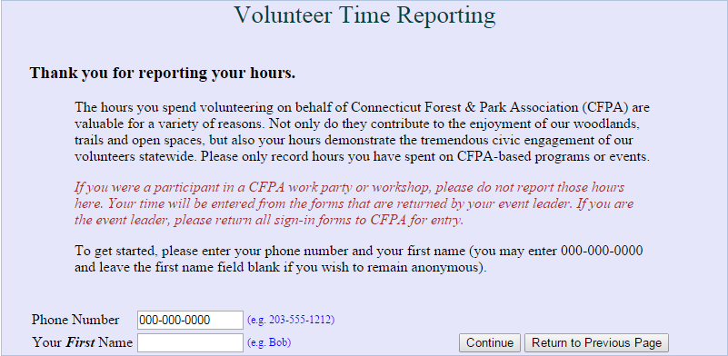
If it is your first time accessing the Volunteer Time Reporting System, the site will recognize you as a new volunteer and prompt you to enter more information; such as your mailing and email addresses.
If you have accessed this site previously, the top of this site will say “Hello (first name). Your last entry was made on: (Date) at: (Time). So far you have recorded a total of (number) hours for the current reporting year.” Contact the Events and Volunteer Coordinator if you feel there is any error in the information given by the system.
You have the following options for inputting your hours: 1.) report every time you volunteer, 2.) report your hours quarterly, 3.) report your hours as one lump sum at the end of the Volunteer Year (August 31st is the end date of the Volunteer Year). We suggest finding a process that works for you. The Events and Volunteer Coordinator can assist you in this process, if needed.
Most importantly, don’t agonize about choosing the correct category or about doing something wrong – just use your best judgment.
The following pages include more detailed information on the time entry process. If you still have questions or need more information, please contact the Events and Volunteer Coordinator.
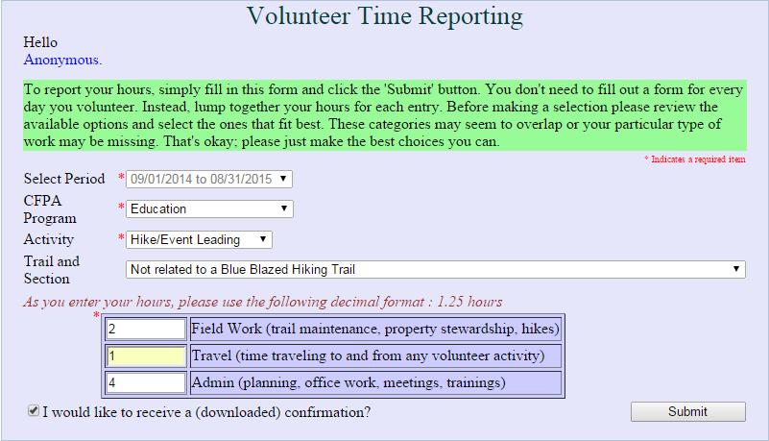

Select Period
The Volunteer Year runs from September 1st to August 31st. Between August 31st and October 31st, the shoulder season, you will be given the option to choose the year in which your hours will be reflected. Please be sure you are reporting your hours for the correct Volunteer Year. After October 31st, you will not be able to submit previous Volunteer Year hours through this system.
Example Scenario 1: Liz volunteered and led a Ramble on August 12, 2014. On September 12th, she logged into the Volunteer Time Reporting site. She noted in the “Select Period” field she had the option of “09/01/2013 to 08/31/2014” or “09/01/2014 to 08/31/2015.” She would select the “09/01/2013 to 08/31/2014” option and those hours will be reflected in the 2014 Volunteer Year.
Example Scenario 2: Liz volunteered and led a Ramble on September 1, 2014. On September 12th, she logged into the Volunteer Time Reporting site. She noted in the “Select Period” field she had the option of “09/01/2013 to 08/31/2014” or “09/01/2014 to 08/31/2015.” She would select the “09/01/2014 to 08/31/2015” option and those hours will be reflected in the 2015 Volunteer Year.
Example Scenario 3: Liz volunteered and led a Ramble on August 12, 2014. On October 12th, she logged into the Volunteer Time Reporting site. She noted in the “Select Period” field that it did not give her the ability to choose the period. The system will not allow you to submit hours for the previous Volunteer Year. Liz will need to contact the Events and Volunteer Coordinator in order to have these hours reflected in the 2014 Volunteer Year.

CFPA Program
Work done on a volunteer basis at the Goodwin Forest Conservation Center, in the James L. Goodwin State Forest, or on the Richard D. Haley Native Wildlife Garden will be submitted to the “Goodwin Center” program.

Activity
Please tell us what volunteer activity you were performing for the hours you are submitting. Please submit separate records for the different activities in which you participate. These categories may seem to overlap or your work may seem to be missing, just make the best choice you can. Your choices are:
- Garden Gang
- General
- Hike/event leading
- Meeting
- Property monitoring
- Special events
- Trail maintenance
- Trails committee
- Workshop (leading)
- Workshop (attending)

Trail and Section (ONLY USED FOR TRAIL MAINTENANCE)
Please only utilize this field if submitting hours for trail maintenance. While it is important to see where our hikes and other activities are (or are not) taking place, we record that information in a different way.

Hours
This is not just the time you gave during the actual volunteer activity but rather all your preparation time in addition to the service time. The hours must be entered as numerals only and in decimal format (e.g. 1 ½ hours should be entered as 1.5). There are three classifications of hours that we ask you to detail; field work, travel, and admin. We use the hours reported by our volunteers to determine the level of commitment to expect for specific volunteer positions and to determine what projects need more attention.
- Field work – How long did it take to do your trail maintenance? How long were you on a property performing monitoring duties? How long was the hike you led?
- Travel – How long did it take you to get to and from the volunteer activity? Please detail the roundtrip travel time.
- Admin – Did you spend three hours planning a hike? How long did you spend on your pre-hike? Did you spend a half hour sending emails to work party participants? We want to know how much of your time you gave to the project before and/or after completing your volunteer activity. This is often the most under-reported portion of a volunteer’s time and we would love to know all of your efforts.

Hours (continued)
As with the other options on this form, please use your best judgment and be as accurate as possible but do not become anxious over a few minutes. If your drive is 25 minutes to your volunteer site and 25 minutes home then list travel time as 1 hour.

A record for you?
There is an option to receive a confirmation of the record submitted. Check the box in the bottom left corner to receive this confirmation of submission.
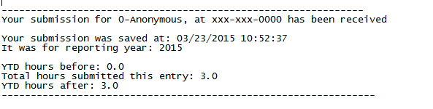
Your Time Reporting Records are reviewed by the CFPA Events and Volunteer Coordinator monthly.

