THE SUCCESS RATE OF AN EASTERN BLUEBIRD
NESTING BOX TRAIL

The Eastern Bluebird, Sialia sialis, is a medium-sized, bright blue, migratory bird with a melodius song. The brilliant color and song make the bluebird a favorite with birders and non- birders alike. They are insectivores, or omnivores and are found in woodlands, farmlands and orchards.

During the era of frontier development, conversion of forest to farmland, orchards and homesites created ideal habitat for the bluebird. Further, wooden fenceposts provided additional nesting sites. These factors led to a proliferation of bluebirds in the eastern United States through the mid-1800’s.

In the late 19th century, introduction of the English house sparrow and European starling began a period of bluebird population decline. These invasive species competed with the bluebird for nesting sites and often destroyed bluebird eggs and nestlings. In the 20th century, the use of harmful pesticides, metal fence posts, clearing field borders and growing human populations led to serious bluebird population reductions.

Fortunately, the favored status and acceptance of nesting boxes helped bring bluebird populations to sustainable levels. Placement of thousands of nesting boxes has contributed significantly to ensuring a future for the bluebird. This success is an excellent example of sound wildlife management practices.

As part of the Master Naturalist Certification program, a research project was required.
The objective of the my project was to evaluate the success rate of an established eastern bluebird nesting box trail at the Flanders Nature Center in Woodbury, CT. I would like to share the results with you because they further serve to validate the careful use of nesting boxes in helping to achieve sustainable levels of certain valued avian species.

Twenty-one (21) nesting boxes of standardized design, as detailed by the North American Bluebird Society (NABS), were fastened to metal fence posts. Standardized baffles were used to discourage unwanted predators, such as snakes, mice, raccoons, etc.

The boxes were placed near open sites such as meadows, hay fields, or smaller open areas of early successional forest. All boxes were in sight of trees, either forest or tree lines, giving the birds a recommended perching area (Figure 1). The boxes were placed in pairs, except for one, to encourage the bluebird/tree swallow relationship. These two species do not compete for the same food source. The tree swallow catches insects while in flight, while the bluebird catches insects on the ground. The tree swallow is extremely territorial and aggressively fights off and any invading species except the bluebird. As such, the bluebird is offered protection by the swallow’s behavior.

The nesting boxes were cleaned in mid-April 2014 in preparation for the nesting season. All previous nesting materials were discarded and the boxes scraped clean. The boxes were monitored every three to four days through the end of August, when the last of the nestlings fledged.

Data were collected in accord with guidelines established by Nest Watch, The Cornell Lab of Ornithology (Appendix III). Date of visits were recorded, as was host species, number of eggs, live young, dead young, nest status, adult and young status

Monitoring the nesting boxes alerts you to problems the birds may be having with predators and competitors. For example, the English House Sparrow can aggressively seize the nesting box and destroy the eggs or nestlings. While it is illegal to evict any songbird from a nesting box, it is strongly suggested that any House Sparrows be captured, euthanized and eggs destroyed.

When all data from the nesting season were collected, it was shared with Nest Watch and with the NABS through Nest Watch.

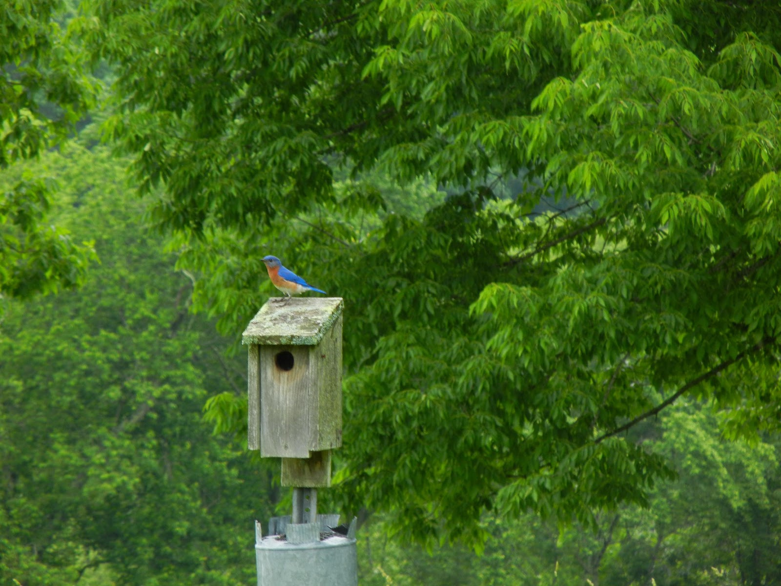

FIGURE 1. Eastern bluebird atop a nesting box of standardized design with predator baffle in place.

Results obtained over a two (2) year period are as follows. Both in 2014 and 2015, the first bluebird egg was observed on April 25th. A typical bluebird clutch is shown in Figure 2.

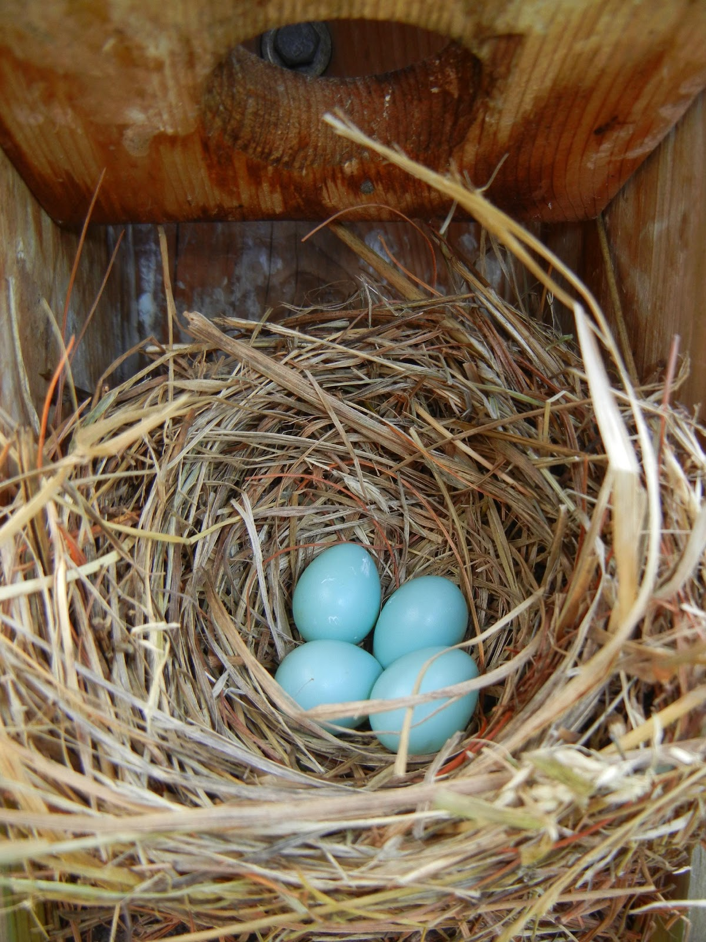

FIGURE 2. Typical bluebird egg clutch, usually numbering four or five eggs per clutch.

With most cavity nesters, one egg is laid each day until the entire clutch is complete. Incubation then begins. For bluebirds, incubation typically lasts 12-14 days. After hatching, the nestlings remain in the nest for about 17-21 days. Figures 3-5 show typical bluebird nestlings at various stages in their development.

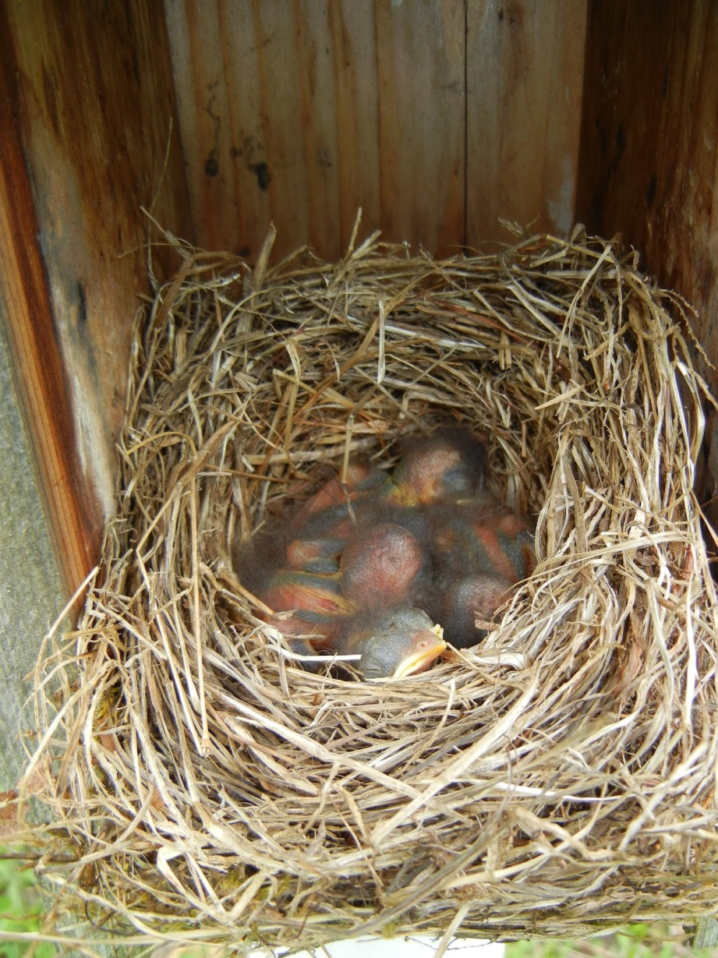

FIGURE 3. Newly hatched bluebirds, naked and pink with eyes typically closed.

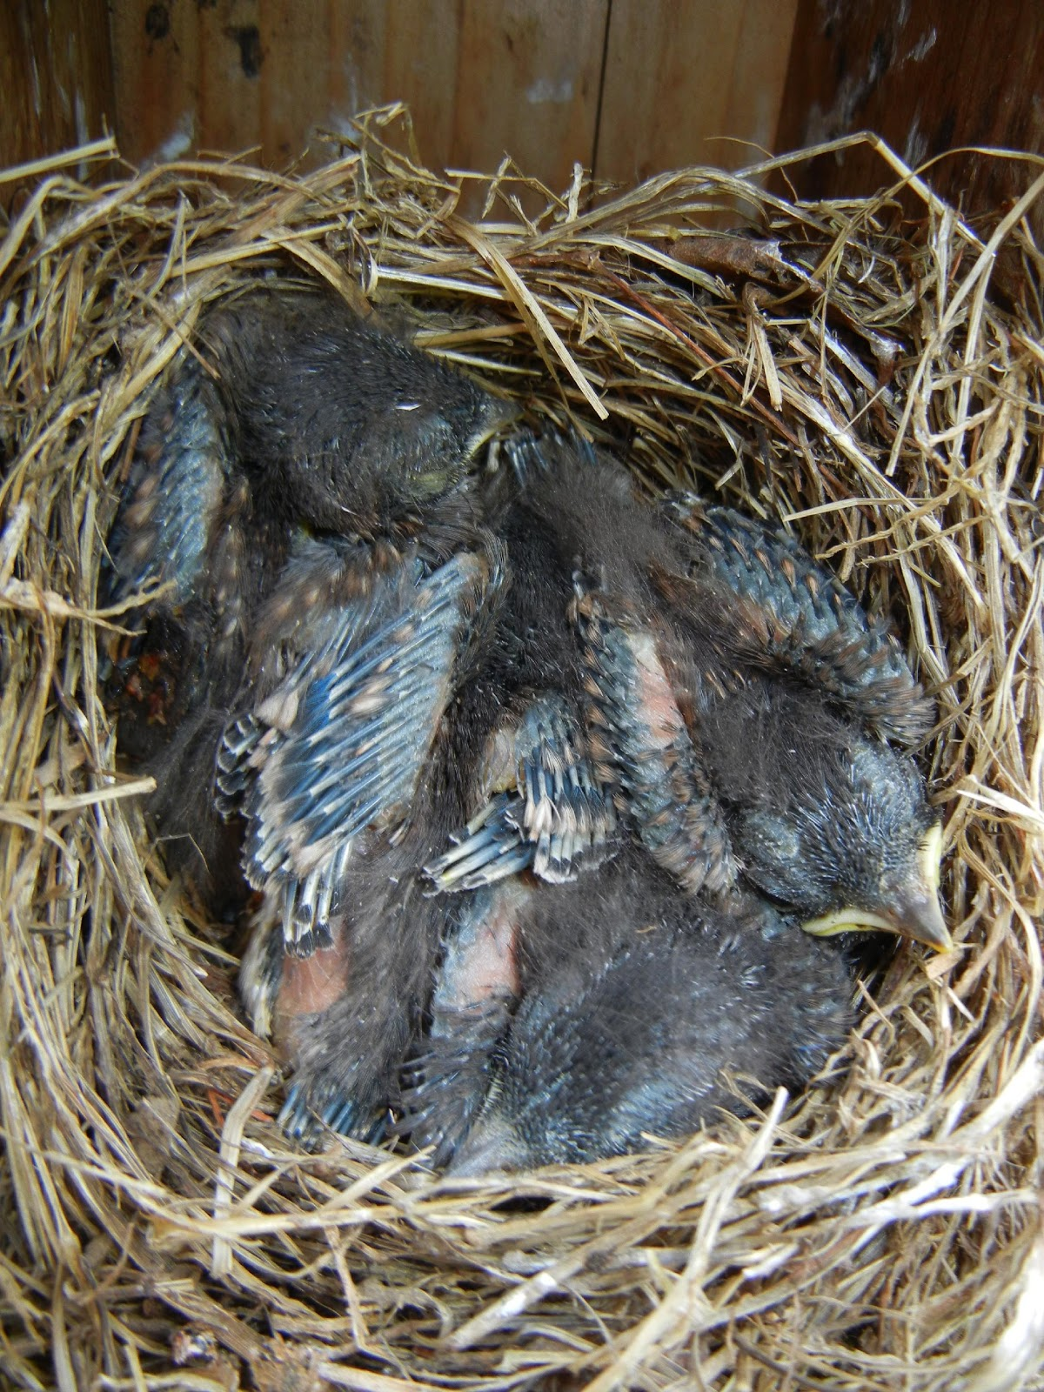

FIGURE 4. Nestlings with wing feathers emerging, some skin still visible and eyes may
be open.

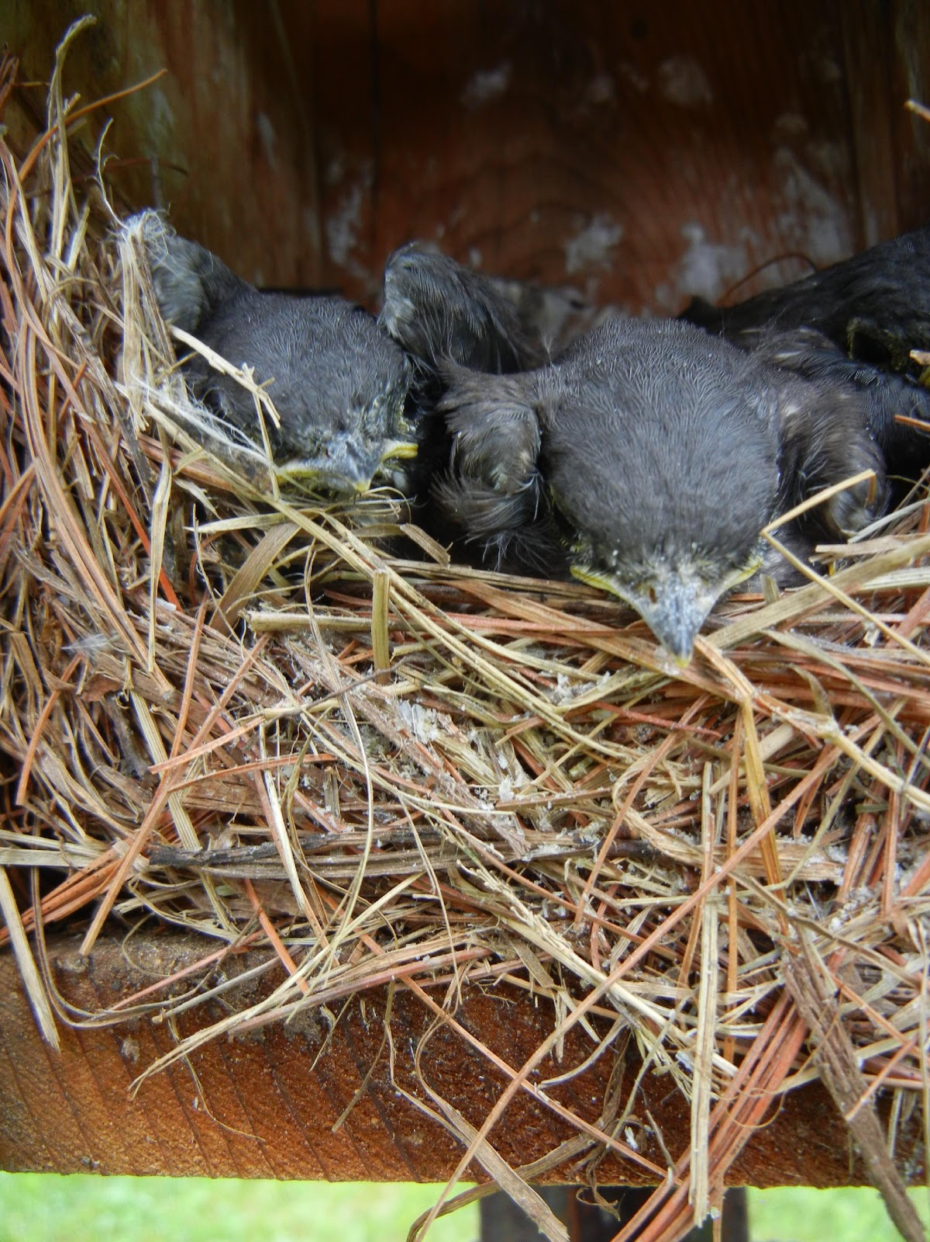

FIGURE 5. Older nestlings nearing fledging. Exhibiting typical opossum behavior when
the nesting box is open.

For 2014, using twenty-one (21) nesting boxes, thirty (30) nesting attempts were observed. Of these, there were fifteen bluebird (15), six (6) tree swallow and five (5) house wren attempts. There were seven (7) second broods, five (5) bluebirds and two (2) house wrens. There were four (4) unproductive nesting attempts; two (2) failed nests, one (1) egg clutch went missing after approximately one (1) week and one (1) egg clutch was destroyed. The evidence suggests vandalism on the part of a house wren. Holes were poked into a clutch of tree swallow eggs and thrown from the nest. No further nesting was attempted by any species in this box through the remainder of the breeding season.

Nesting success is based on the total number of eggs and fledglings for each species. For 2014, success rates of 91.6%, 71.4% and 90.9% were observed for the bluebird, tree swallow and house wren species, respectively.

For 2015, using twenty-one (21) nesting boxes, twenty-nine (29) nesting attempts were observed. Of these, there were thirteen bluebird (13), nine (9) tree swallow and one (1) house wren attempts. There were seven (7) second broods, five (5) bluebirds and two (2) tree swallows. There were six (6) unproductive nesting attempts; one (1) failed nest, three (3) nests with nestlings missing and two (2) egg clutches were destroyed.

For 2015, success rates of 86.1%, 77.0% and 26.6% were observed for the bluebird, tree swallow and house wren species, respectively.

In conclusion, based on data collected during the course of this project, the Flanders Nature Center’s bluebird nesting box trail was highly successful in providing nesting sites for cavity nesting avian species, particularly the eastern bluebird. For 2004, thirty (30) nesting attempts in the twenty-one (21) boxes comprising the trail produced fifty-five (55) bluebird, twenty (20) tree swallow and twenty (20) house wren fledges, respectively.

For 2015, Twenty-nine (29) nesting attempts in the twenty-one (21) boxes comprising the trail produced fifty-six (56) bluebird, thirty-seven (37) tree swallow and four (4) house wren fledges, respectively.

