James L. Goodwin Conservation Center’s
Master Naturalist Program

Dear Applicant,
Thank you for your interest in the James L. Goodwin Conservation Center’s Master Naturalist Program. This two level program is designed for people who want to expand their knowledge and awareness of the natural environment. Participants will receive in depth instruction, both in the classroom and the field, on a comprehensive range of topics, including plants, soils, birds, habitats, mammals, forestry, and aquatic systems.
The classroom training will be held at the James L. Goodwin Conservation Center in Hampton CT, with field studies at various locations across the state in addition to the Center. Following the 8 week formal instruction period students will participate in a variety of activities including a short research project, special educational programs at the Center, field trips and educational outreach.
The Level I certification, Apprentice Naturalist, is a pre-requisite for the Level II Master Naturalist certification. The Level II training is a more intense program, with participants concentrating on one or two selected topic areas and more in depth research project.
Enclosed please find information on the application process as well as the application form, program requirements, and fees. If you have any further questions, feel free to contact the James L. Goodwin Conservation Center.
James L. Goodwin Conservation Center
23 Potter Rd, Hampton, CT 06247
Phone: 860-455-9534; E-mail: deep.goodwin@ct.gov

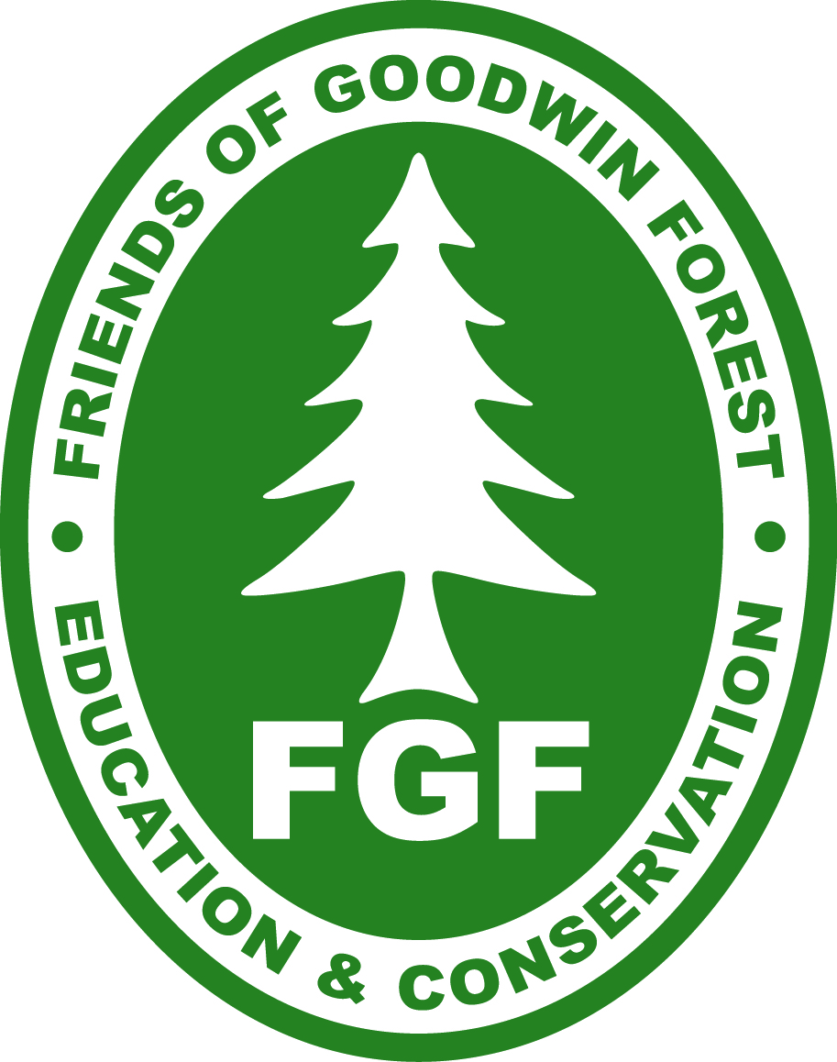

James L. Goodwin Conservation Center’s
2017 Master Naturalist Program
LEVEL I
APPLICATION PROCESS
- A completed application must be postmarked by Friday, March 17th, 2017 and submitted to the James L. Goodwin Conservation Center, 23 Potter Rd. Hampton, CT 06247.
- Letters of acceptance will be mailed by Monday, March 27th, 2017.
- If accepted into the program, payment in the form of a check for $250.00 must be postmarked no later than Wednesday April 10th, 2017.

PROGRAM REQUIREMENTS
APPRENTICE NATURALIST (Spring 2017)

35 + hours formal classroom/field training consisting of 8 classes. Attendance mandatory on 4/29. Students are expected to attend all sessions, with one excused absence.

4/29, 5/6, 5/13, 5/20, 6/4, 6/10, 6/17, 6/24 9:00AM-3:00PM
- Short research project 4-7 hours with report on the findings.
- Attend at least one (1) field trip.
- Attend at least three (3) out of of ten (10) special programs offered as a part of the James L Goodwin Conservation Center’s Environmental Education Series
- 25 hours of educational outreach.
- All requirements completed by September 10th, 2017
- Must be 16 years or older.
MASTER NATURALIST (Fall 2017)
- Successful completion of Apprentice Naturalist, Level I
- 35 + hours formal classroom/field training consisting of 7 classes taught by specialist in their fields.
- Focus area of research in one or two topics
- Research project in area of focus and report on the findings.
- Attend at least one (1) field trip.
- Attend at least two(2) of five special ‘programs’ offered as a part of the Goodwin Centers Environmental Education Series
- 25 hours of educational outreach at the Goodwin Center.

COURSE MATERIALS
- Participants will receive a Master Naturalist manual, field notebook, textbook and hand lens

2017 James L. Goodwin Conservation Center’s
Master Naturalist Application
Please type or print:
Last Name: First Name:
Name as you wish it to appear on your name tag:
Street Address:
City: | State: Zip: County:
Phone Days: | Evenings: Cell:
E-mail: | County of residence:
Occupation, if employed: | Former occupation, if retired:
Emergency Contact Name: | Emergency Contact Phone #:

For the following questions, use additional sheets if necessary
1. List any training or experience in environmental education, research, stewardship, or related areas. In what area(s), if any, do you specialize; e.g. native plants, forestry, management, etc.?
2. Why do you wish to take the Master Naturalist training?
3. How did you learn about the Master Naturalist program?
5. Master Naturalist activities span a broad range of educational outreach opportunities. If you are accepted into the Master Naturalist program, will you be able to complete your 25 hours of outreach by September 12th 2017?
Yes No, please explain
6. Please rate your expertise in the following areas:
1 = experienced 2 = some knowledge 3 = none
Forestry Management | Birds | Soils
Wetlands | Amphibians/Reptiles | Ecology
Interpretation/Teaching | Insects | Natives/Invasives
Lakes/Ponds | Mammals | Plants/Trees
Rivers/Streams
8. Please list any additional skills, interests and hobbies that you have.
9. Please list organizations or clubs in which you are active.
13. Classroom materials will be posted on our web site and we will communicate primarily through email. Do you have internet access? If not, is there someone who can assist you?

Work experience (List most recent experience first)
Employer | Position or title | # of Years

Enrollment in the James L. Goodwin Conservation Center’s Master Naturalist program is limited and competitive. We may conduct telephone or personal interviews. The Master Naturalist Program periodically documents classes through photography and video for publicity purposes. Registration in the James L. Goodwin Conservation Center’s Master Naturalist Program includes permission to photograph you and use you your image in publicity materials unless you inform the photographer that you do not wish to have your photograph taken.

Partial scholarships based on financial need may be available. Please check if you would like to receive a scholarship application. ________
Do not send payment unless you receive a letter of acceptance.
No walk-ins accepted.

I acknowledge that I have read and understand all of the above.

Signature______________________________________________ Date ___________

