FRIENDS OF GOODWIN MEMBERSHIP RENEWAL

We believe the primary benefit to our members rests in the knowledge that, through your support, the Friends of Goodwin State Forest continues to help manage the forest and 17+ mile trail system, restore the facilities of the conservation Center and help create an effective education program for people of all ages.

Please consider supporting both the Friends of Goodwin Forest (FGF) and our fiscal sponsor Connecticut Forest & Park Association (CFPA) by choosing the Goodwin Circle level. This unique partnership provides greater resources to enhance and expand Goodwin programs, facilities, trails and forest conservation around the state.

MEMBERSHIP LEVELS:
Basic $25 •Receive FGF’s e-newsletter and early notification of special events, discounts for
plant sales and certain educational programs.
Goodwin Circle $60 (Dual FGF/CFPA Membership) The above, plus:
•A subscription to CFPA’s quarterly magazine Connecticut Woodlands.
•Voting privileges at Annual and Special meetings.
•A mailed copy of the Connecticut Trails Day brochure.
•Invitations to programs, meetings, workshops, etc.
•Discounts at CFPA online store.

Invite a friend to join the Friends of Goodwin Forest or give a FGF Membership as a gift. (friendsofgoodwinforest.org)

_________________________________________CUT HERE____________________________________________

MEMBERSHIP RENEWAL

Choose one:    Basic $25 - Friends of Goodwin Forest membership only.
Goodwin Circle $60 – Dual membership in Friends of Goodwin Forest AND Connecticut
Forest & Park Association

Name__________________________________________________________ Address_________________________________________________________
City_____________________________State___________Zip_____________
Phone___________________________________email______________________________________

Enclosed is my check in the amount of $___________(for dues)
and an additional contribution to FGF of $___________ for a total of $___________

or charge your gift: Mastercard Visa #______________________________________________________
Expiration Date_________________________ CSV code_______________________
Signature__________________________________________________________________________

 Check here if you do not wish CFPA to disclose your contact information.

MAKE CHECKS PAYABLE TO: CFPA/FGF
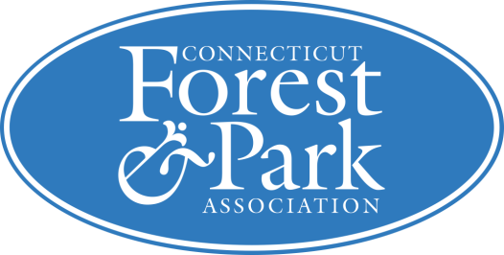
Mail to: CFPA/FGF, 16 Meriden Road, Rockfall, CT 06481
Friends of Goodwin Forest physical address: 23 Potter Rd, Hampton, CT

