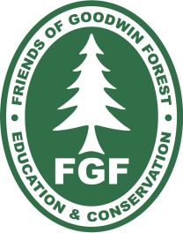
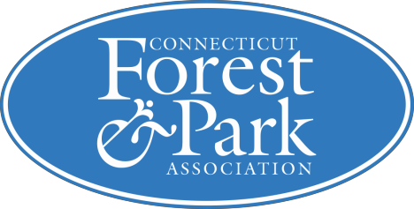

CHAINSAW TRAINING
for the

NOVICE & AMATEUR

Safe & Productive Chainsaw Use Through
“THE GAME OF LOGGING II”

Certified Training Program,

Sponsored by

The James L. Goodwin Conservation Center

& The Friends of Goodwin Forest

This program is designed for amateur users who wish to improve their skills and to operate their saw safely. This is a “hands-on” course. Students bring their own saws, practice the skills taught and have the opportunity to fell trees under the guidance of a professional instructor. Topics covered include: reduced down time maintenance, sharpening, bar and sprocket maintenance, spring poles and tree felling.

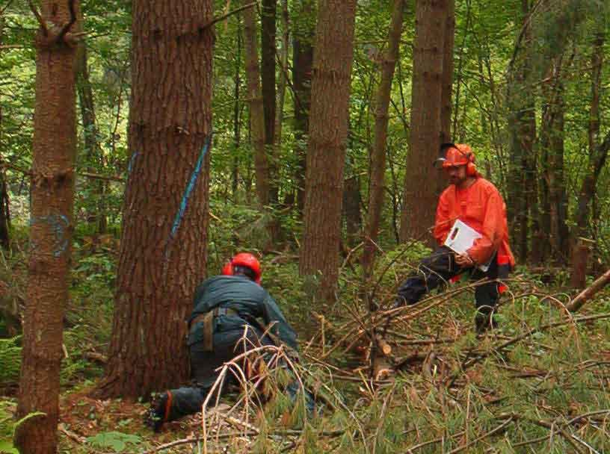Instructor Bill Girard of Girard Custom Cut Hardwoods is a Certified Instructor for the world-renowned “Game of Logging” chainsaw training program. He has been a full-time logger for over 30 years, and owns and operates a variety of logging equipment.

WHEN: Saturday, July 29th
(8:00 am-4:30 pm)

WHERE: James L. Goodwin Conservation Center in Hampton, CT
COST: $120 per person; $100 for Friends of Goodwin Forest and CFPA members

For more information contact Jasper Sha at 860-455-9534 or jasper.sha@ct.gov
Registrations are required for this program and are taken on a first come, first served basis
Space is limited.

Detailed instructions and directions to the site will be sent as part of a confirmation e-mail message when payment and registration are received.

REGISTRATION FORM—GOL Level II, July 22nd, 2017. Please print clearly and mail with payment (checks made payable to CFPA/FGF) to: Beth Bernard, Goodwin Conservation Center, 23 Potter Road, Hampton CT, 06247.
Registration and payment must be received by 7/22/17.

Name:

Address: City/State/Zip

Tel: Email:

Amount Enclosed:

